eCMS MANUAL

Annual Exemption User Manual

Department of Revenue and Customs
Ministry of Finance
Table of Contents
1. Logging In FE user: 1
2. Create Exemption 1
3. Track Application 4
4. Cancel Exemption 4

Introduction

Annual exemption is for the manufacturing unit, we apply for the exemption of the raw material for a year use. So this document provided the process of how to create the annual exemption and link it to the declaration as a subsequent process.

Logging In FE user:

- The user needs to log into eCMS using the url: www.ecms.gov.bt
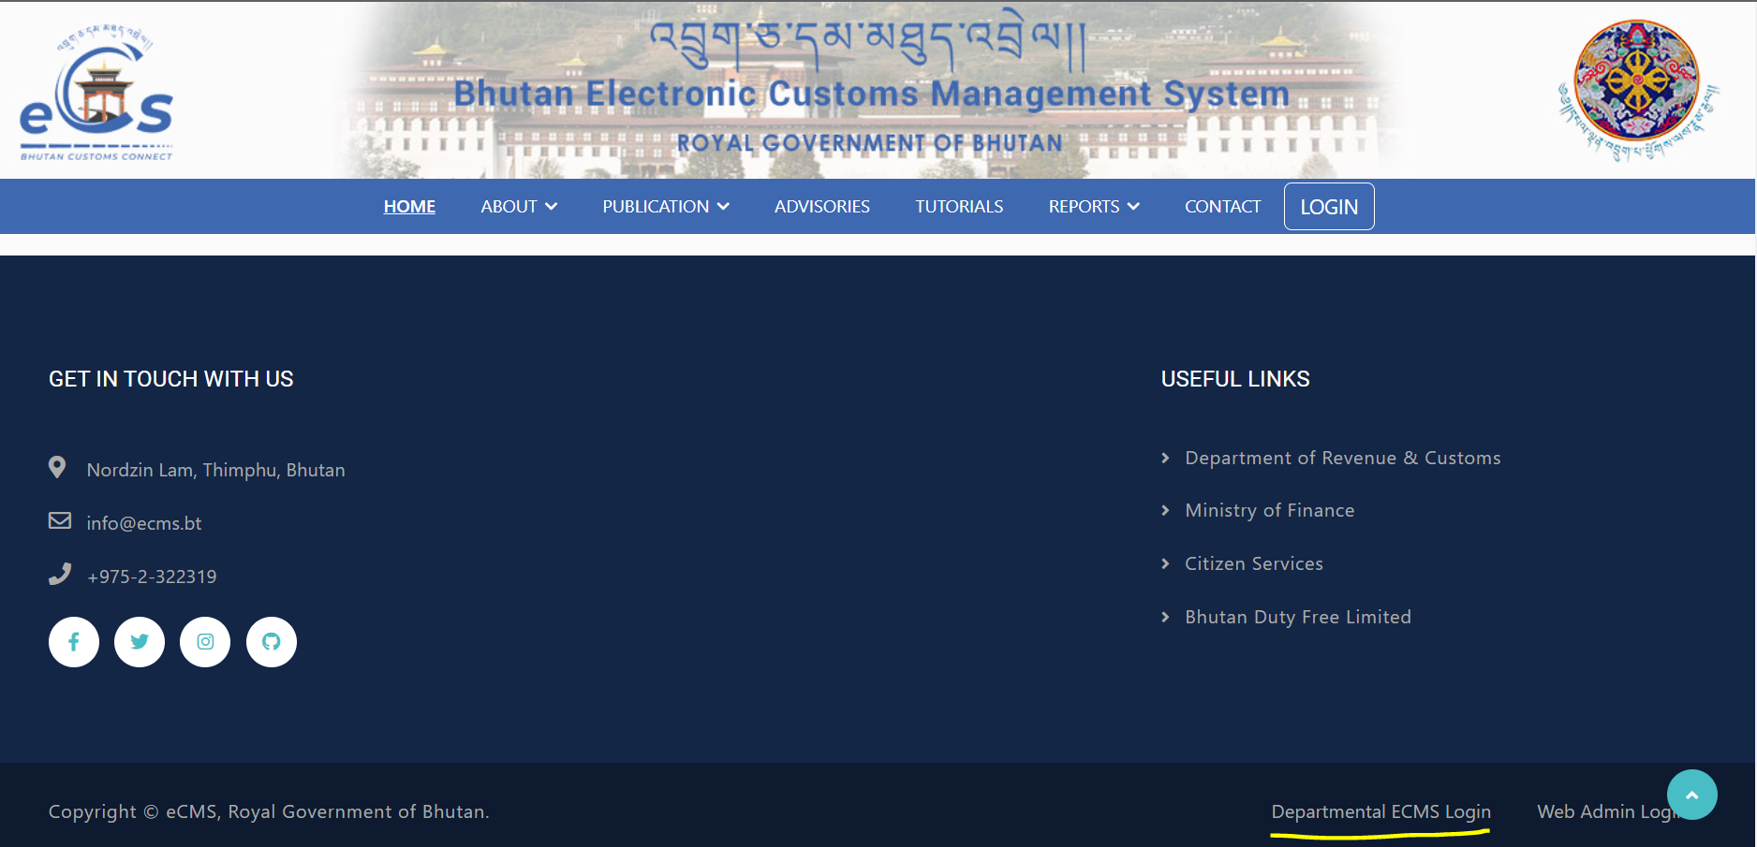
- Click on login menu and provide the required credentials to log in to the system:
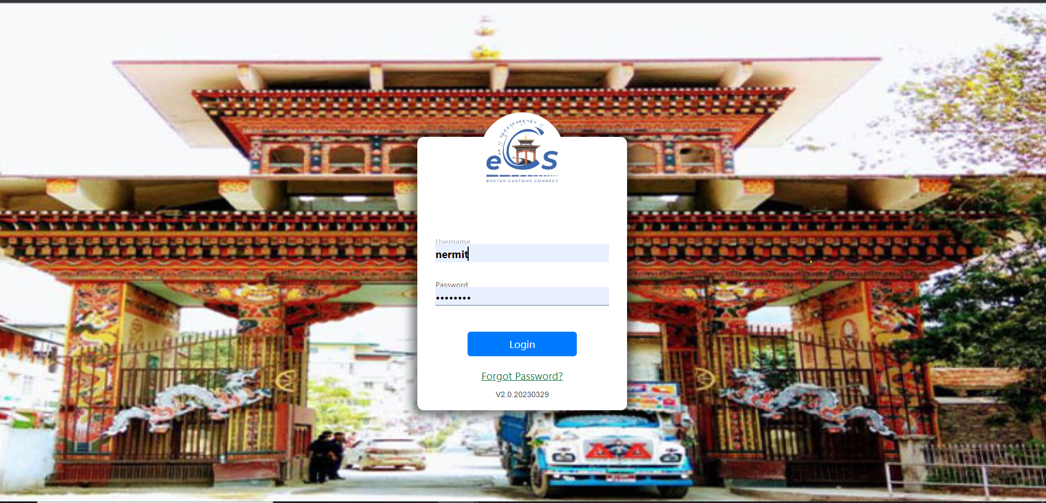

Create Annual Exemption
- Select Exemption from the list of menus provided in the dashboard:
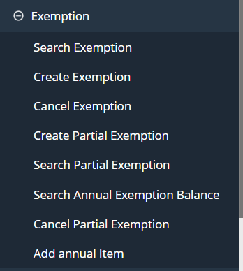

- Under the Exemption menu, Select Create Exemption:

- Key in the details under each menu provided:

  - General information: details related to the exemption:

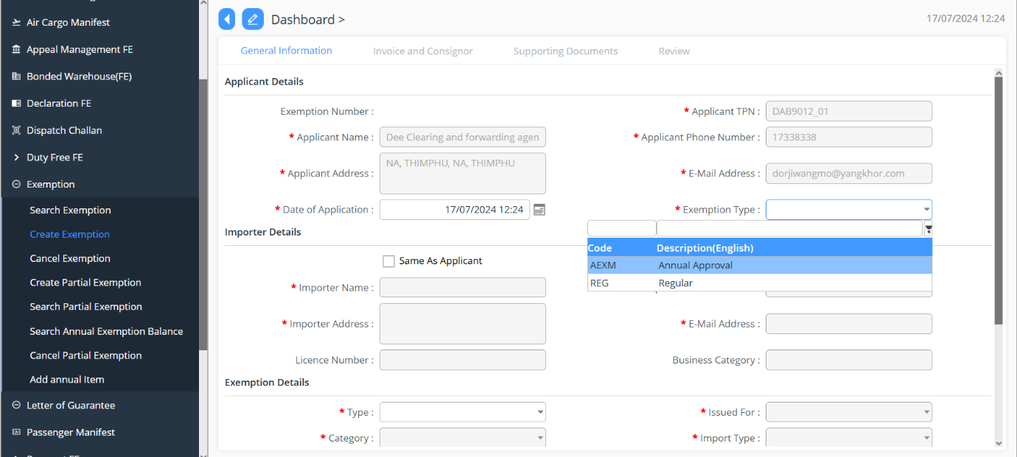
Here select exemption type as Annual Approval.

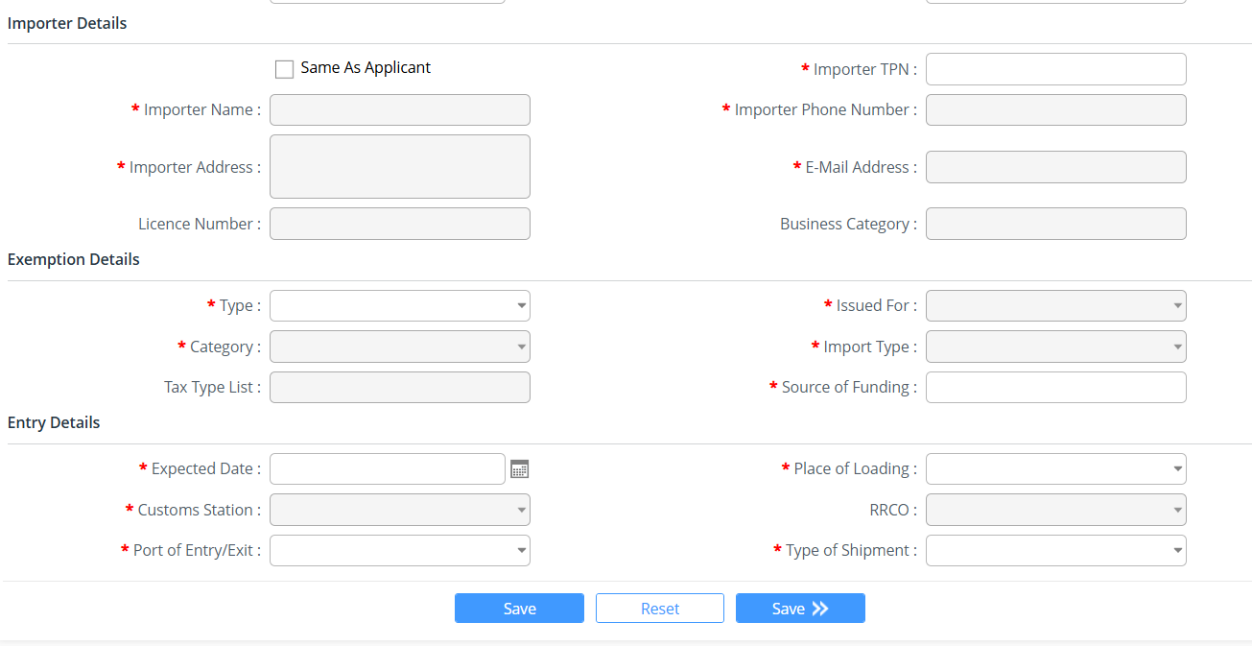

Fill in the details accordingly

  - Invoice and Consignor: add in the details of invoice:
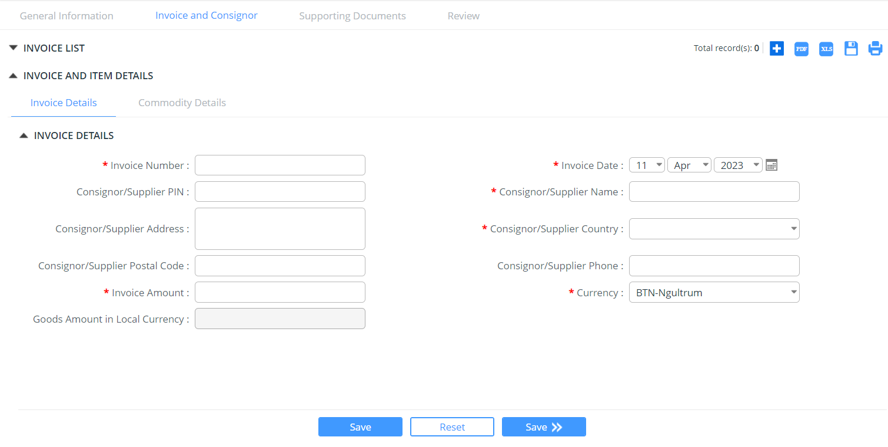

  - Supporting document: upload the mandatory doc listed under this tab, if no mandatory document reflected, we can upload the document for proof by clicking on + button to add the doc you wish to add:

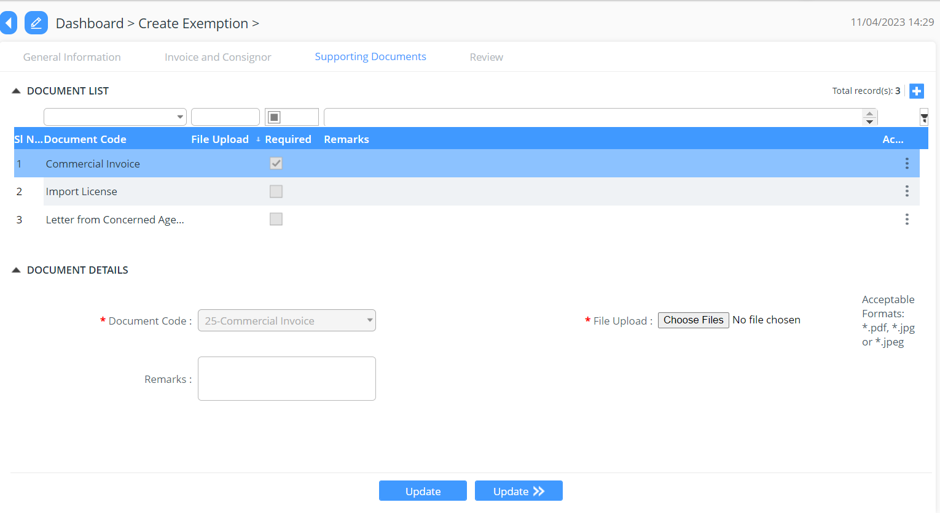

  - Summary: provide the summarized details of the detailed filed in for passenger manifest

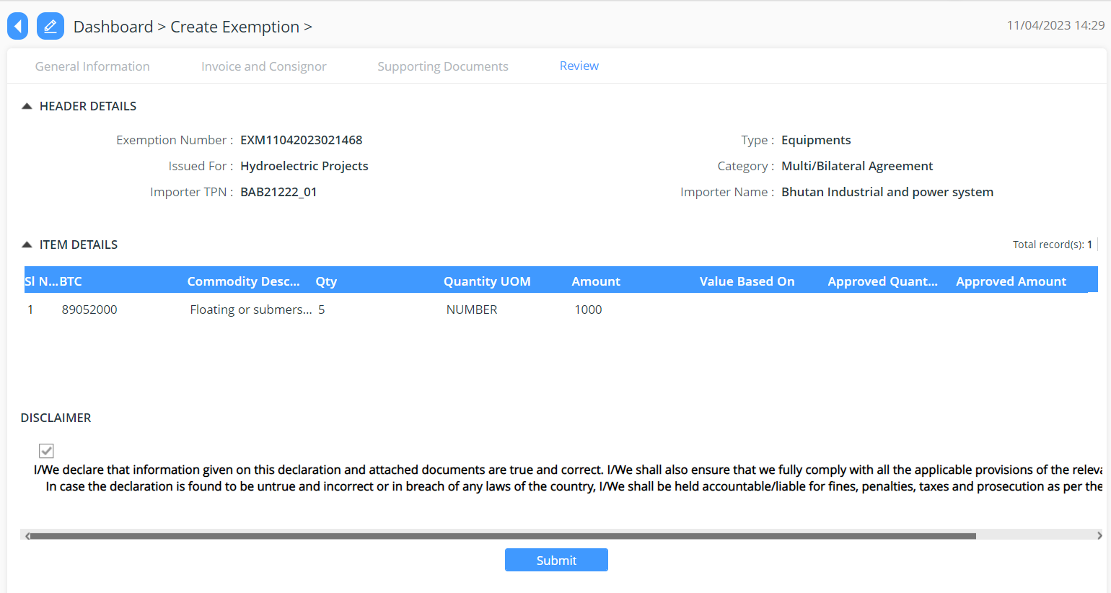

Track Application
- An application Number will be Generated:

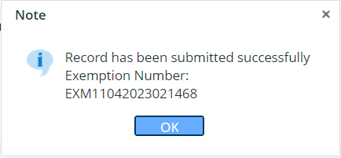

- The users will be able to track their application from search exemption:

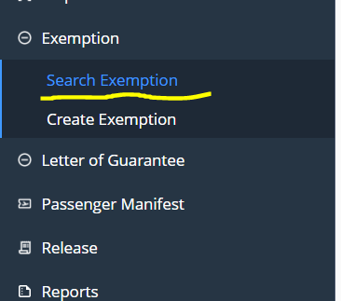

Cancel Exemption
- The applicant can cancel the exemption request in certain cases for that, from the list of exemption under the cancel exemption tab:
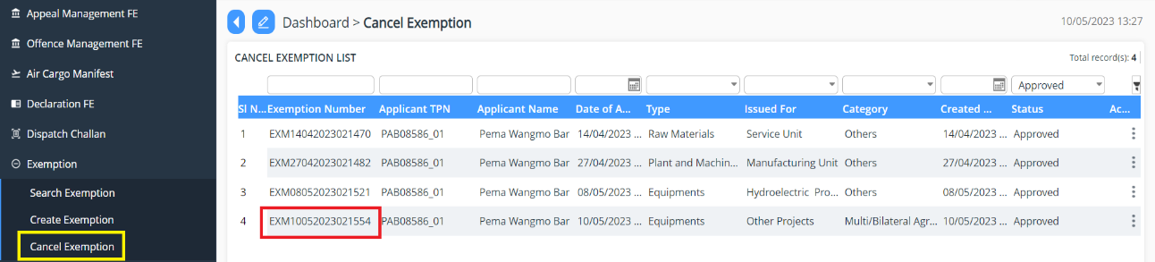

- Select the exemption you wish to cancel and provide the reason for the same and submit the same:
